PROJECT DEVELOPMENT PHASEDELIVERY OF SPRINT-3

|  |  |
| --- | --- |
| Date | 09-11-2022 |
| Team ID | PNT2022TMID31937 |
| Project Name | Retail Store Stock Inventory Analytics |

**Sprint-1:**

**PROJECT DEVELOPMENT PHASE:**

**Sprint-3:**

* Data Collection
* Dashboard Creation

**Sprint-2:**

* + Data Preparation
* Data Exploration

**Sprint-4:**

* Report Creation
* Story Creation

**DATA COLLECTION:**

Download the Dataset

Dataset link - [https://us3.ca.analytics.ibm.com/bi/?perspective=dashbord&pathRef=.public_folders%2FVisualiz](https://us3.ca.analytics.ibm.com/bi/?perspective=dashbord&pathRef=.public_folders%2FVisualization%2FData%2BExploration&action=view&mode=dashboard) [ation%2FData%2BExploration&action=view&mode=dashboard](https://us3.ca.analytics.ibm.com/bi/?perspective=dashbord&pathRef=.public_folders%2FVisualization%2FData%2BExploration&action=view&mode=dashboard)

**LOAD THE DATASET:**

Tool used – IBM Cognos

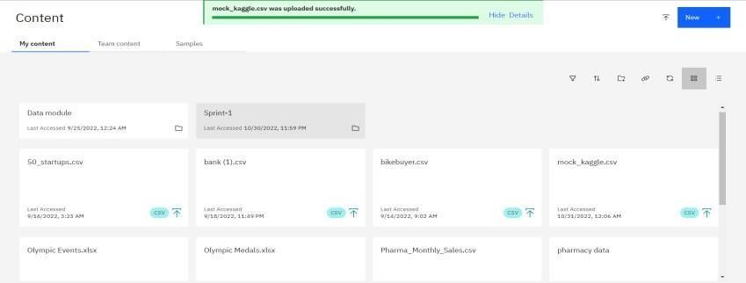

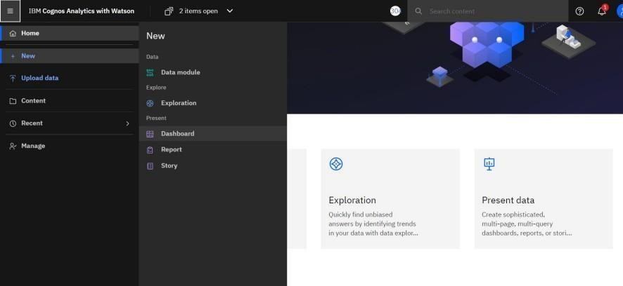

Create a Dashboard:

